**PROJECT ON DESKTOP A.I ASSISTANT MODULE**

**Team Members: Siddanna M D [4PM21AI042] Varshini T Naik[4PM21AI052]**

Name of collage :- K.B.P . collage , Vashi

Name of Department : Computer Science

Student Name :- Anjali Nanasaheb Lankeshwar

Roll No. :- 217532

Subject :- Project on Desktop A.I Assistant Module

ABSTRACT

As we know Python is an emerging language so it becomes easy to write a script for Voice

Assistant in Python. The instructions for the assistant can be handled as per the requirement

of user. Speech recognition is the process of converting speech into text. This is commonly

used in voice assistants like Alexa, Siri, etc. In Python there is an API called

SpeechRecognition which allows us to convert speech into text. It was an interesting task

to make my own assistant. It became easier to send emails without typing any word,

Searching on Google without opening the browser, and performing many other daily tasks

like playing music, opening your favorite IDE with the help of a single voice command. In

the current scenario, advancement in technologies are such that they can perform any task

with same effectiveness or can say more effectively than us. By making this project, I

realized that the concept of AI in every field is decreasing human effort and saving time

Name of collage :- K.B.P . collage , Vashi

Name of Department : Computer Science

Student Name :- Anjali Nanasaheb Lankeshwar

Roll No. :- 217532

Subject :- Project on Desktop A.I Assistant Module

ABSTRACT

As we know Python is an emerging language so it becomes easy to write a script for Voice

Assistant in Python. The instructions for the assistant can be handled as per the requirement

of user. Speech recognition is the process of converting speech into text. This is commonly

used in voice assistants like Alexa, Siri, etc. In Python there is an API called

SpeechRecognition which allows us to convert speech into text. It was an interesting task

to make my own assistant. It became easier to send emails without typing any word,

Searching on Google without opening the browser, and performing many other daily tasks

like playing music, opening your favorite IDE with the help of a single voice command. In

the current scenario, advancement in technologies are such that they can perform any task

with same effectiveness or can say more effectively than us. By making this project, I

realized that the concept of AI in every field is decreasing human effort and saving time

**ABSTRACT:**

As we know Python is an emerging language so it becomes easy to write a script for Voice Assistant in Python. The instructions for the assistant can be handled as per the requirement of user. Speech recognition is the process of converting speech into text. This is commonly used in voice assistants like Alexa, Siri, etc. In Python there is an API called Speech Recognition which allows us to convert speech into text. It was an interesting task to make my own assistant. It became easier to send emails without typing any word, searching on Google without opening the browser, and performing many other daily tasks like playing music, opening your favourite IDE with the help of a single voice command. In the current scenario, advancement in technologies is such that they can perform any task with same effectiveness or can say more effectively than us. By making this project, I realized that the concept of AI in every field is decreasing human effort and saving time.

**INTRODUCTION:**

Artificial Intelligence when used with machines, it shows us the capability of thinking like humans. In this, a computer system is designed in such a way that typically requires interaction from human. As we know Python is an emerging language so it becomes easy to write a script for Voice Assistant in Python. The instructions for the assistant can be handled as per the requirement of user. Speech recognition is the Alexa, Siri, etc. In Python there is an API called Speech Recognition which allows us to convert speech into text. It was an interesting task to make my own assistant. It became easier to send emails without typing any word, searching on Google without opening the browser, and performing many other daily tasks like playing music, opening cofavorite IDE with the help of a single voice command. In the current scenario, advancement in technologies is such that they can perform any task with same effectiveness or can say more effectively than us. By making this project, I realized that the concept of AI in every field is decreasing human effort and saving time.

**PRESENT SYSTEM:**

We are familiar with many existing voice assistants like Alexa, Siri, Google Assistant, Cortana which uses concept of language processing, and voice recognition. They listen the command given by the user as per their requirements and performs that specific function in a very efficient and effective manner.

As these voice assistants are using Artificial Intelligence hence the result that they are providing are highly accurate and efficient. These assistants can help to reduce human effort and consumes time while performing any task, they removed the concept of typing completely and behave as another individual to whom we are talking and asking to perform task. These assistants are no less than a human assistant but we can say that they are more effective and efficient to perform any task. The algorithm used to make these assistant focuses on the time complexities and reduces time.

But for using these assistants one should have an account (like Google account for Google assistant, Microsoft account for Cortana) and can use it with internet connection only because these assistants are going to work with internet connectivity. They are integrated with many devices like, phones, laptops, and speakers etc.

**PROPOSED SYSTEM:**

It was an interesting task to make my own assistant. It became easier to send emails without typing any word, searching on Google without opening the browser, and performing many other daily tasks like playing music, opening your favourite IDE with the help of a single voice command. Jarvis is different from other traditional voice assistants in terms that it is specific to desktop and user does not need to make account to use this, it does not require any internet connection while getting the instructions to perform any specific task.

The IDE used in this project is Visual Studio. All the python files were created in Visual Studio and all the necessary packages were easily installable in this IDE. For this project following modules and libraries were used i.e. pyttsx3, Speech Recognition, Datetime, Wikipedia, OpenAI etc. I have created a live GUI for interacting with the JARVIS as it gives a design and interesting look while having the conversation.

With the advancement JARVIS can perform any task with same effectiveness or can say more effectively than us. By making this project, I realized that the concept of AI in every field is decreasing human effort and saving time. Functionalities of this project include, it can send emails, it can read PDF, it can send text on WhatsApp, it can open command prompt, your favourite IDE, notepad etc., It can play music, It Can do Wikipedia searches for you, It can open websites like Google, YouTube, etc., in a web browser, It can give weather forecast, It can give desktop reminders of your choice. It can have some basic conversation.

MODEL-BASED REFLEX AGENTS:

.

**PYTHON LIBRARIES:**

1. Speech Recognition: It is a python module which converts speech to text.
2. os: It represents Operating System related functionality.
3. pyttsx3: It is a python library which converts text to speech
4. Webbrowser: It provides interface for displaying web-based documents to users
5. OpenAI: The OpenAI Python library is a Python 3.7+ application that provides access to the OpenAI REST API. It includes type definitions for all response fields and request params, and offers asynchronous and synchronous clients.
6. Datetime: This library provides us the actual date and time.
7. Random: the random package allows users to generate random numbers.

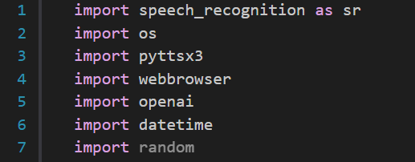

**Fig 1: Libraries used in this project**

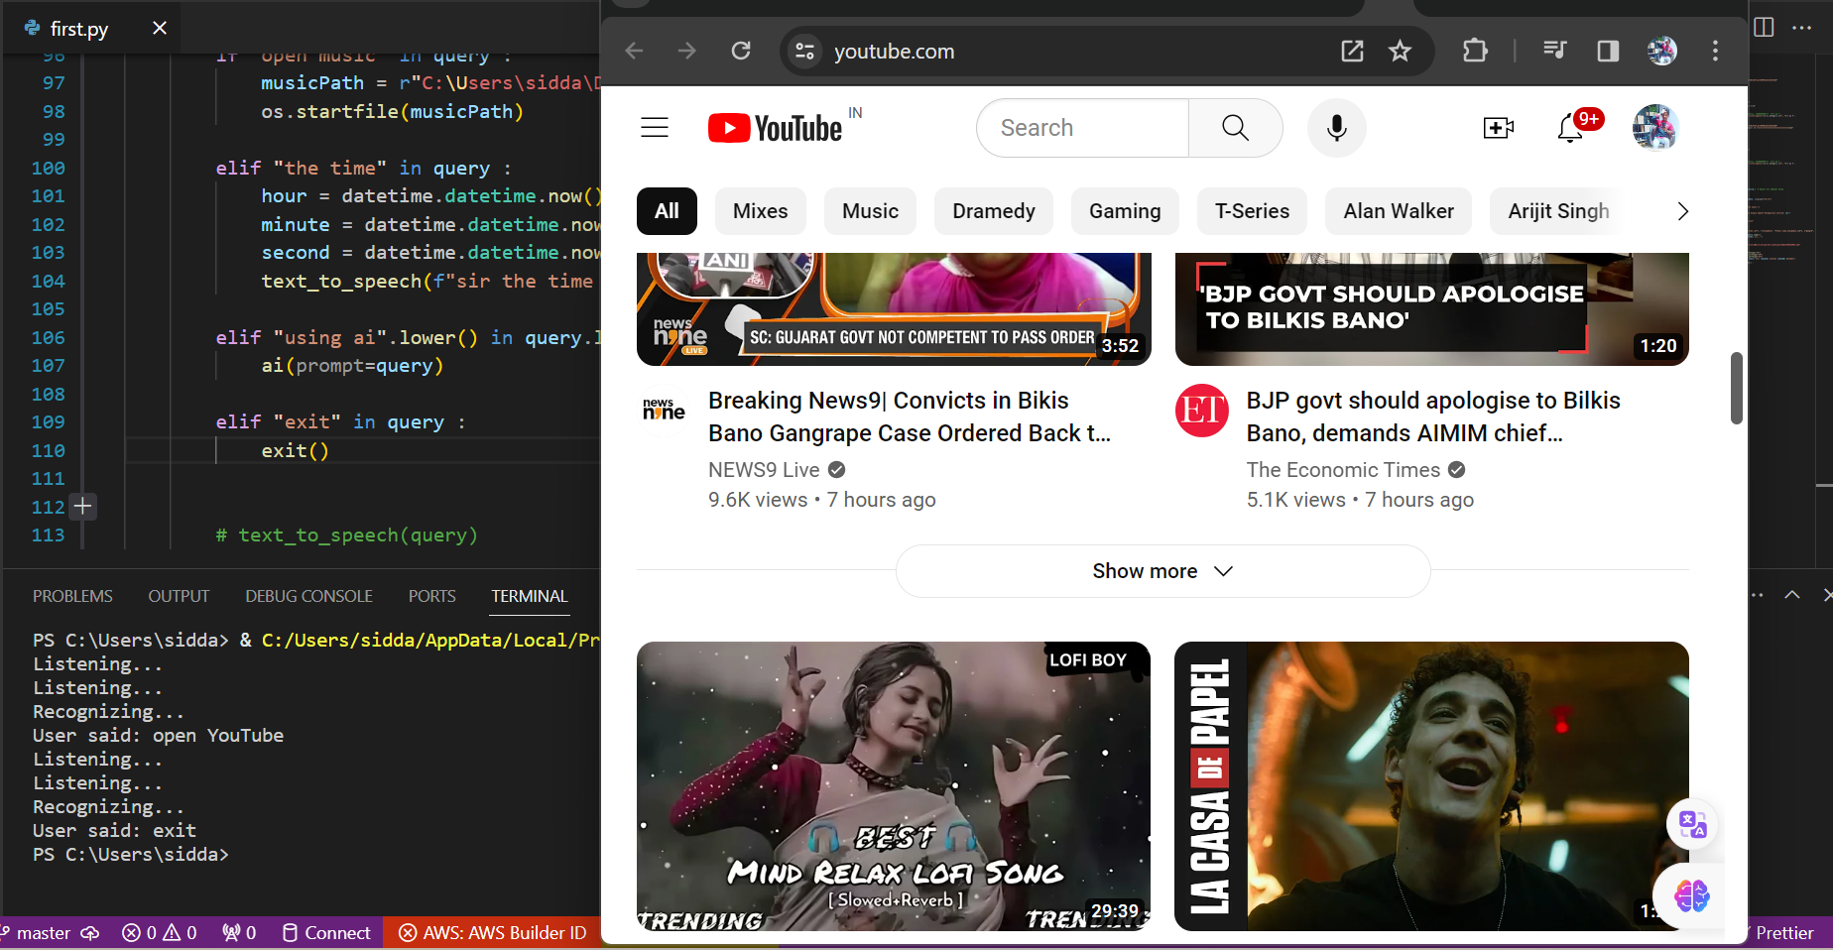

**Fig 2: Output For YouTube search**

**CONCLUSION:**

JARVIS is a very helpful voice assistant without any doubt as it saves time of the user by conversational interactions, its effectiveness and efficiency. But while working on this project, there were some limitations encountered and also realized some scope of enhancement in the future which are mentioned below:

LIMITATIONS:

1. Security is somewhere an issue, there is no voice command encryption in this project.
2. Background voice can interfere.
3. Misinterpretation because of accents and may cause inaccurate results.
4. JARVIS cannot be called externally anytime like other traditional assistants like Google Assistant can be called just by saying, “Ok Google!”